Sensitivity - ability to predict a positive when the outcome is actually positive
Y_guess = 1 when Y_actual = 1

- An algo that treats everything as “positive” has HIGH SENSITIVITY
- So Sensitivity alone is not enough as metric]

Specificity - ability to predict a negative when the outcome is actually negative
Y_guess = 0 when Y_actual = 0

Meaning, “high sensitivity” means Y_actual = 1 implies that Y_guess = 1 and
“high specificity” means Y_actual = 0 implies that Y_guess = 0.

Specificity can also mean:
- the proportion of positive predictions that are actually positive
- “high specificity” can also mean Y_guess = 1 implies that Y_actual = 1

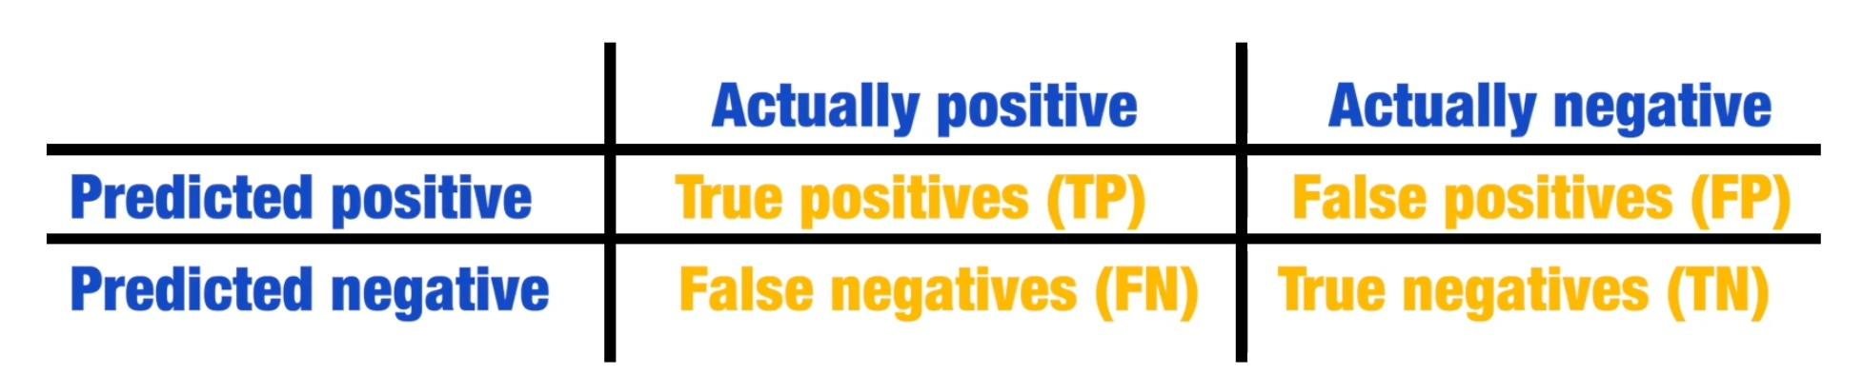

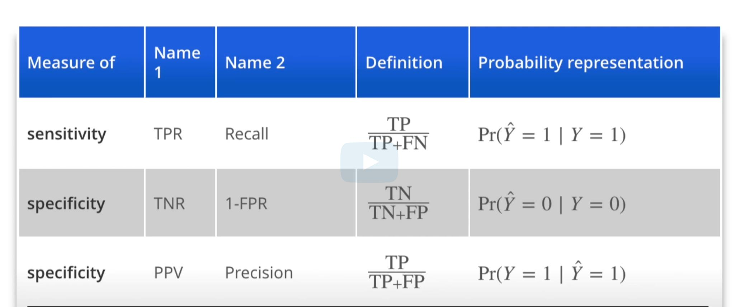

- “recall” - a.k.a. True Positive Rate (TPR)
  - proportion of all actual positives that are actually positive
- “precision” - a.k.a. Positive Predictive Value (PPV)
  - proportion of actual positive from all predicted positive

- True Negative Rate (TNR)
  - proportion of all actual negatives that are actually negative

- “Precision” depends on “Prevalence”
- “Prevalence” is simply the proportion of positives in the data set.
e.g. number of females (positives) vs. number of males (negatives)
- So just having “low Prevalence” can immediately equate to “low Precision”
- And we can have “high accuracy” despite having “low Sensitivity” if we have “low Prevalence”.
  - Nahatak ng negatives yung “accuracy”, kaya di siya enough as a metric
  - Kahit mali yung prediction sa true females, di affected ung accuracy masyado kung mas maraming males sa data set to begin with.
  - Biased data set ibig sabihin.
  - Kaya dapat both Sensitivity at Specificity ung ineexamine.
  - Or, use “Balanced Accuracy” = average of Sensitivity and Specificity
  - Or, since both are rates, use the harmonic average: F1 Score

- confusionMatrix() summarizes this. It expects factors as inputs.

F1 Score: harmonic average of “precision” and “recall”
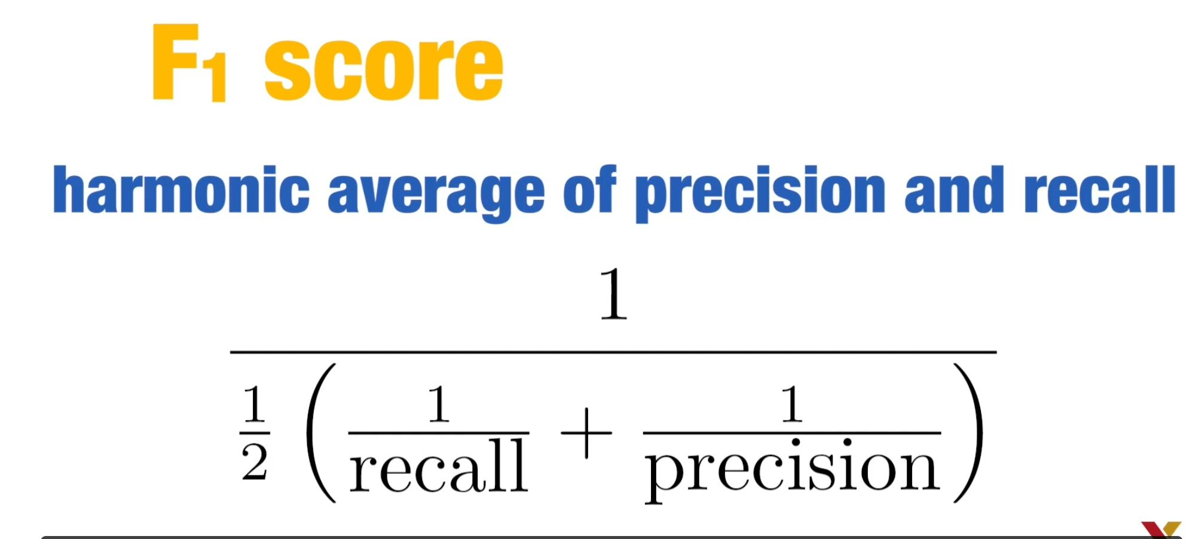

However, sometimes, we want to prioritize one over the other.
- E.g. In plane safety, we want to maximize Sensitivity over Specificity
  - Failing to predict when a plane would malfunction before it crashes
is more costly that failing to predict if the plane can land
when it is in fact, in perfect condition.
- E.g. In capital murder case, the opposite is true.
  - Convicting an innocent person (a false positive) is more costly since it can execute the wrong person.

The F1 Score can be adapted to weigh Specificity and Sensitivity accordingly.
So we define a “beta”:
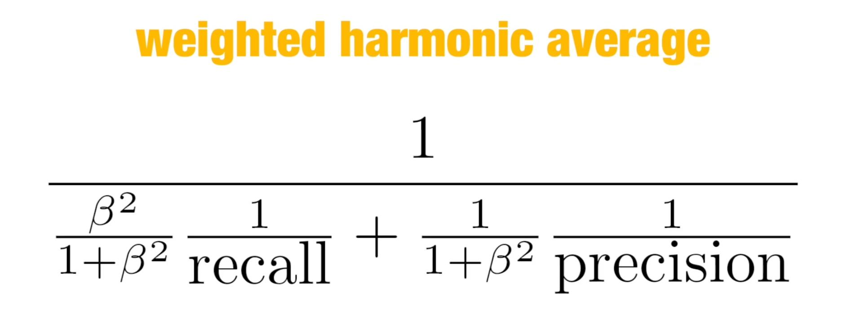

F_meas() from caret() package computes the summary with beta = 1 by default.

In practice, a very high specificity and high sensitivity might not be very useful if the prevalence is close to 0 or 1.

Case Study:

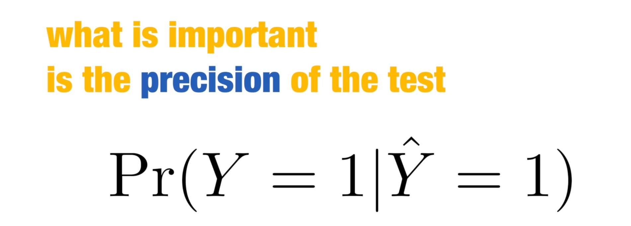

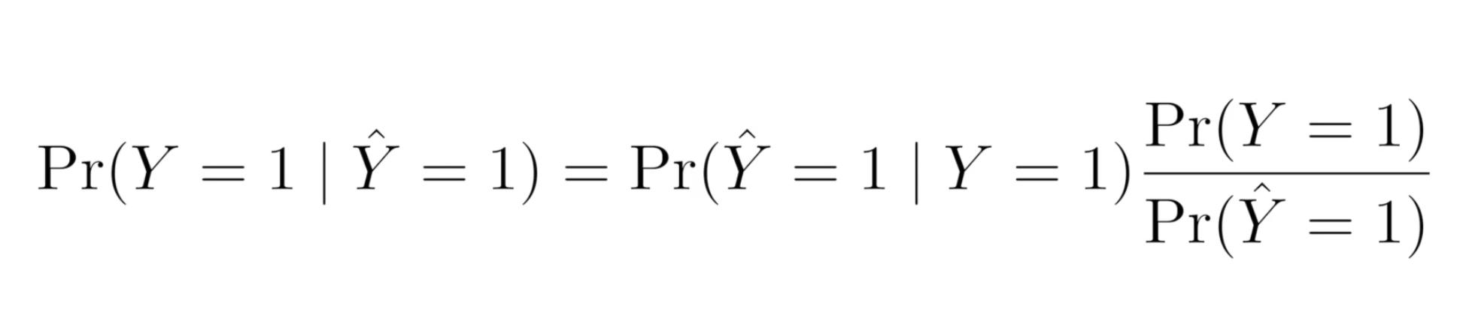

If Pr(Y_actual =1) / Pr(Y_guess) = 1/100 --> (5/1000 prevalence) divided by (½ tested positive)

Then, yung “precision” mo is already less than 1/100, or less than 1%.

Less than 1% yung precision ng algorithm mo.
Sobrang baba.

And precision is what matter sa test, kahit sobrang taas ng sensitivity mo (yung tested positive if positive talaga sa disease.)

------

Receive Operating Characteristic (ROC) curve
- plots Sensitivity (TPR) vs. 1 - Specificity (FPR)
- however, it does not include prevalence

Precision - Recall Plot

Loss Function
- useful for both categorical and continuous data (unlike the 2 plots above, which are useful only for categorical data)
- Squared Loss Function: (y_prediction - y_actual_outcome) ^ 2

Mean Squared Error (MSE):
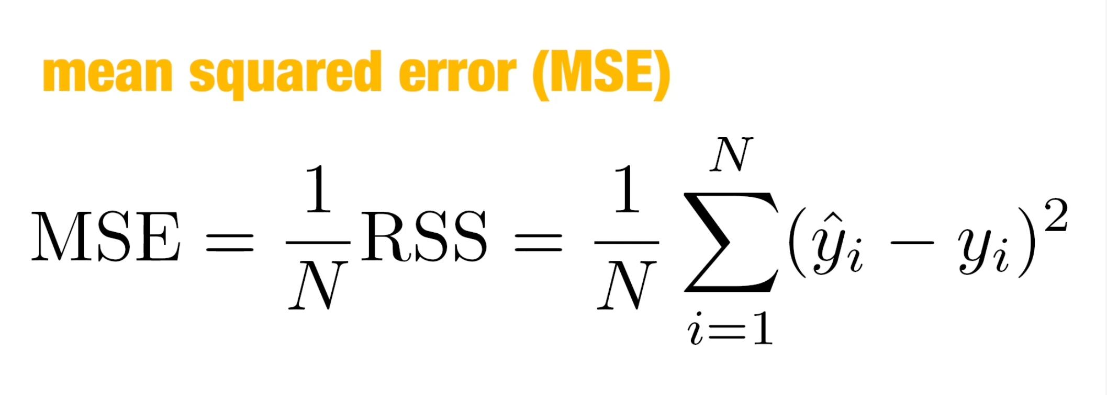
- In practice, we report Root Mean Squared Error (RMSE) because it has the same unit as our outcome. (it is just the square root of MSE)
- In binary outcomes, MSE and RMSE are equivalent to 1 - accuracy
- Because our data is usually a random sample, our MSE can be thought of as a random variable.
- Our observed MSE can be thought of as the estimate of expected MSE:
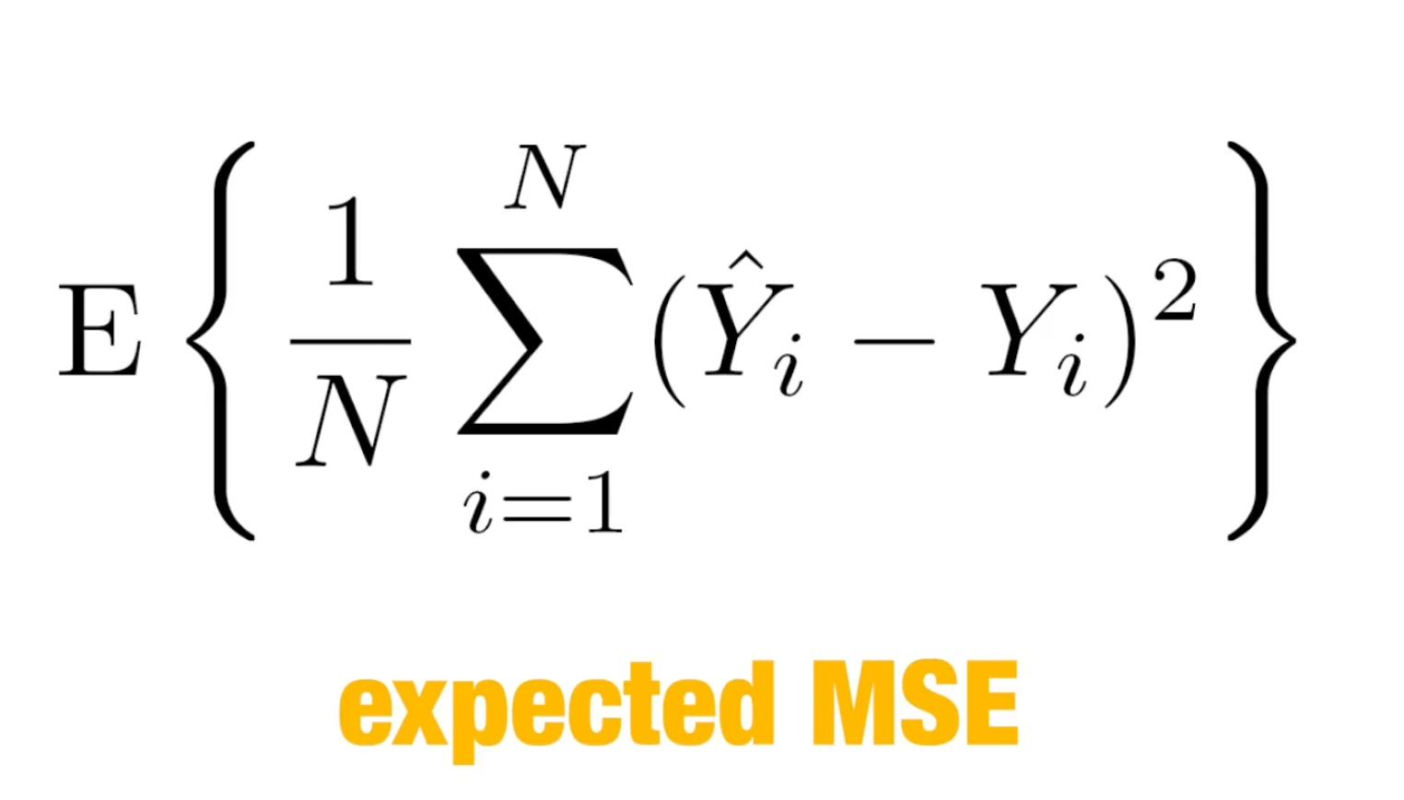
- And in practice, we only have 1 data set we work with, so expected MSE is only theoretical.
- Although, to compute for the expected MSE, we can assume a large number of theoretical data sets (we call that number of samples: B), and get the average MSE across all those samples:
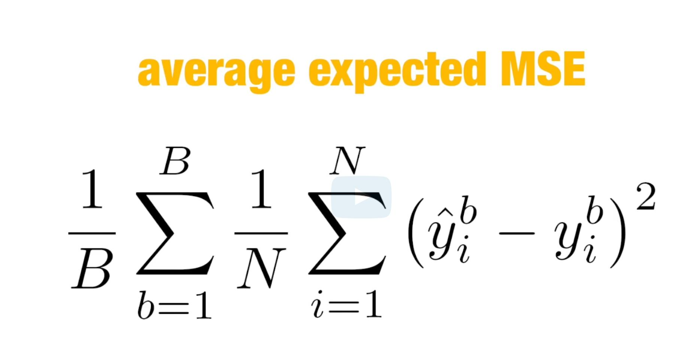

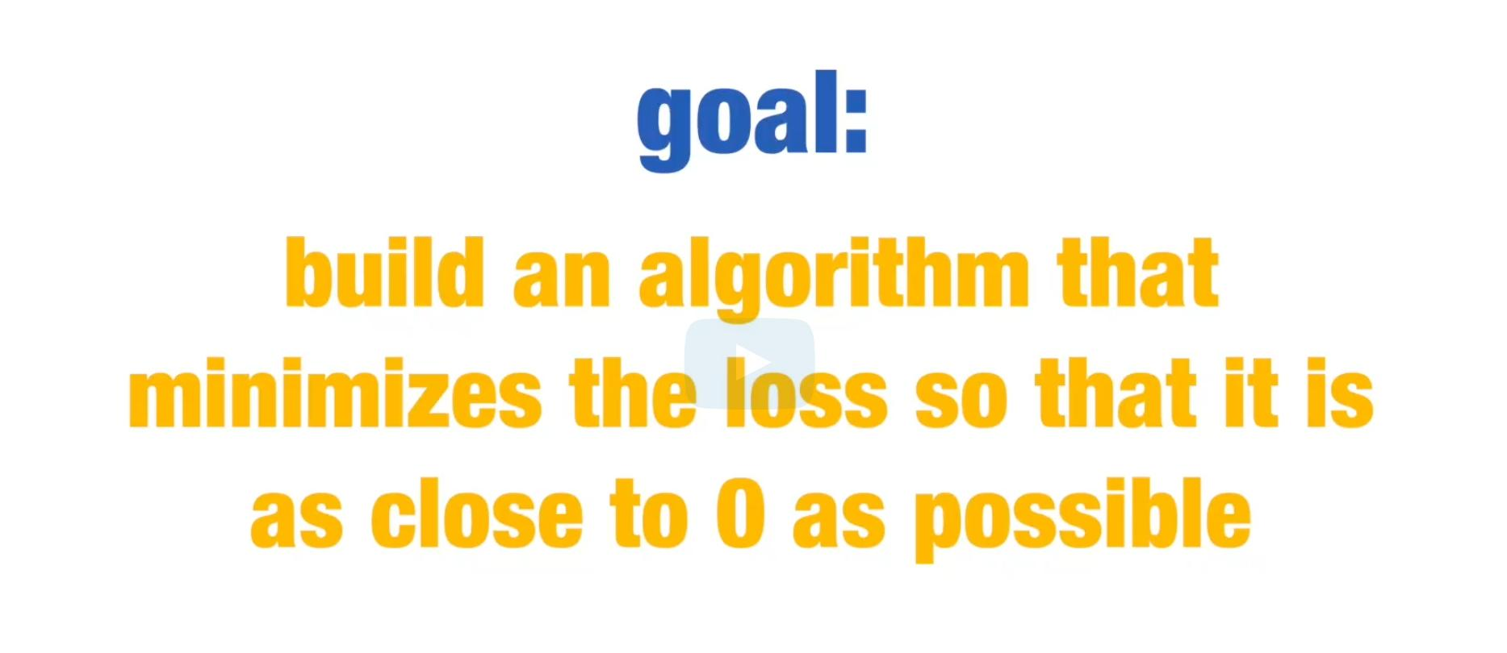

---

Nice Code on train/test data set and creation of algorithm:


set.seed(76)
test_index <- createDataPartition(y, times=1, p=0.5, list=FALSE)
test <- iris[test_index,]
train <- iris[-test_index,]

---
// This sample code can be used to determine that Petal.Width is the most accurate singular feature:

foo <- function(x){
rangedValues <- seq(range(x)[1], range(x)[2], by=0.1)
sapply(rangedValues, function(i){
y_hat <- ifelse(x>i, 'virginica', 'versicolor')
mean(y_hat==train$Species)
})
}
predictions <- apply(train[,-5], 2, foo)
sapply(predictions, max)

---
// This code computes for the accuracy in the Test Data Set

predictions <- foo(train[,4])
rangedValues <- seq(range(train[,4])[1], range(train[,4])[2], by=0.1)
cutoffs <-rangedValues[which(predictions==max(predictions))]

y_hat <- ifelse(test[,4]>cutoffs[1], 'virginica', 'versicolor')
mean(y_hat==test$Species)

getretre

//sheeesh
replicate(t, {
+ indices <- createDataPartition(dat$y, times = 1, list = FALSE, p = 0.5)
test <- dat[indices, ]
train <- dat[-indices, ]
fit <- train %>% lm(y ~ x, data = .)
a_new <- predict(fit, newdata = test, type = "response")
sqrt(mean((a_new - test$y) ^ 2))
})

---

Smoothing:

Since f(x) is almost constant in small windows of time:
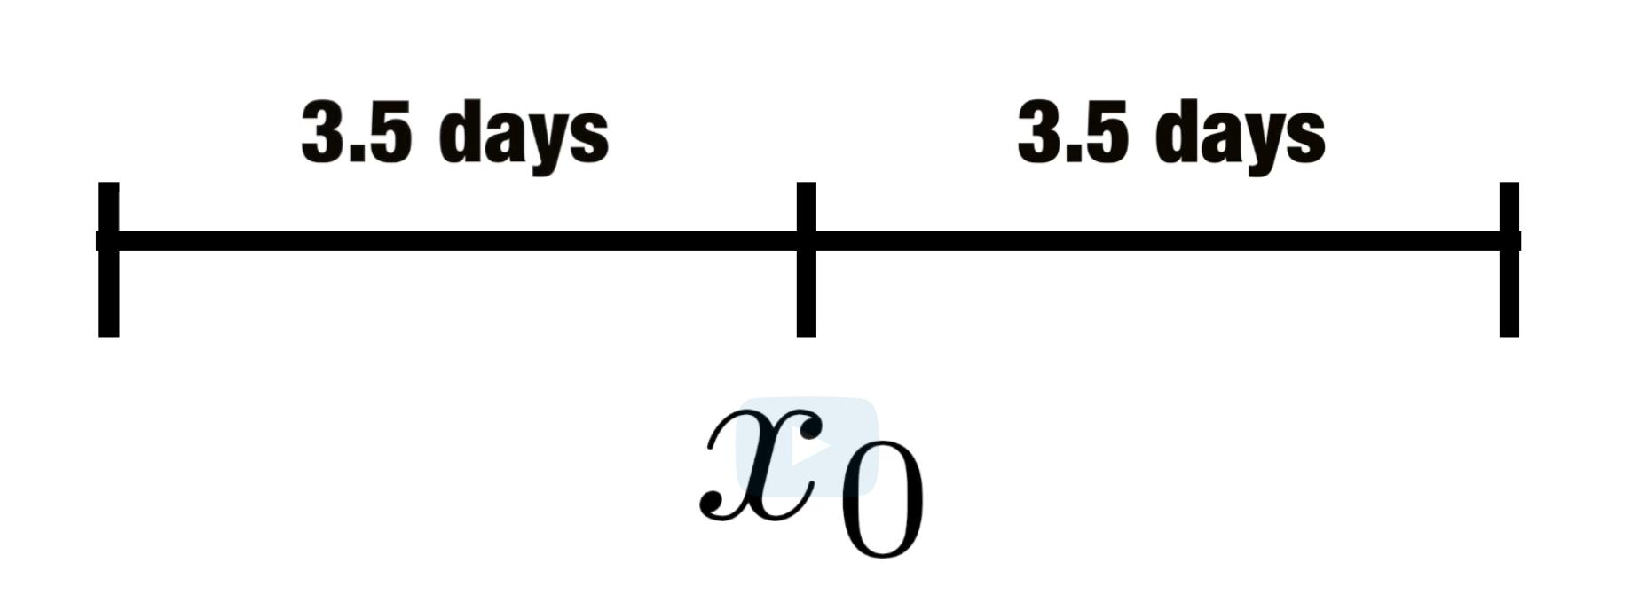

We assume f(xo) = a constant mu for |x-xo| <= 3.5 (aka window size or bandwidth or span) :
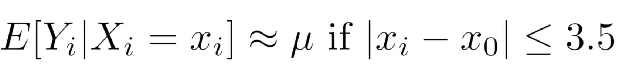

Implies that a good estimate for f(x) is the average of y values within the window:

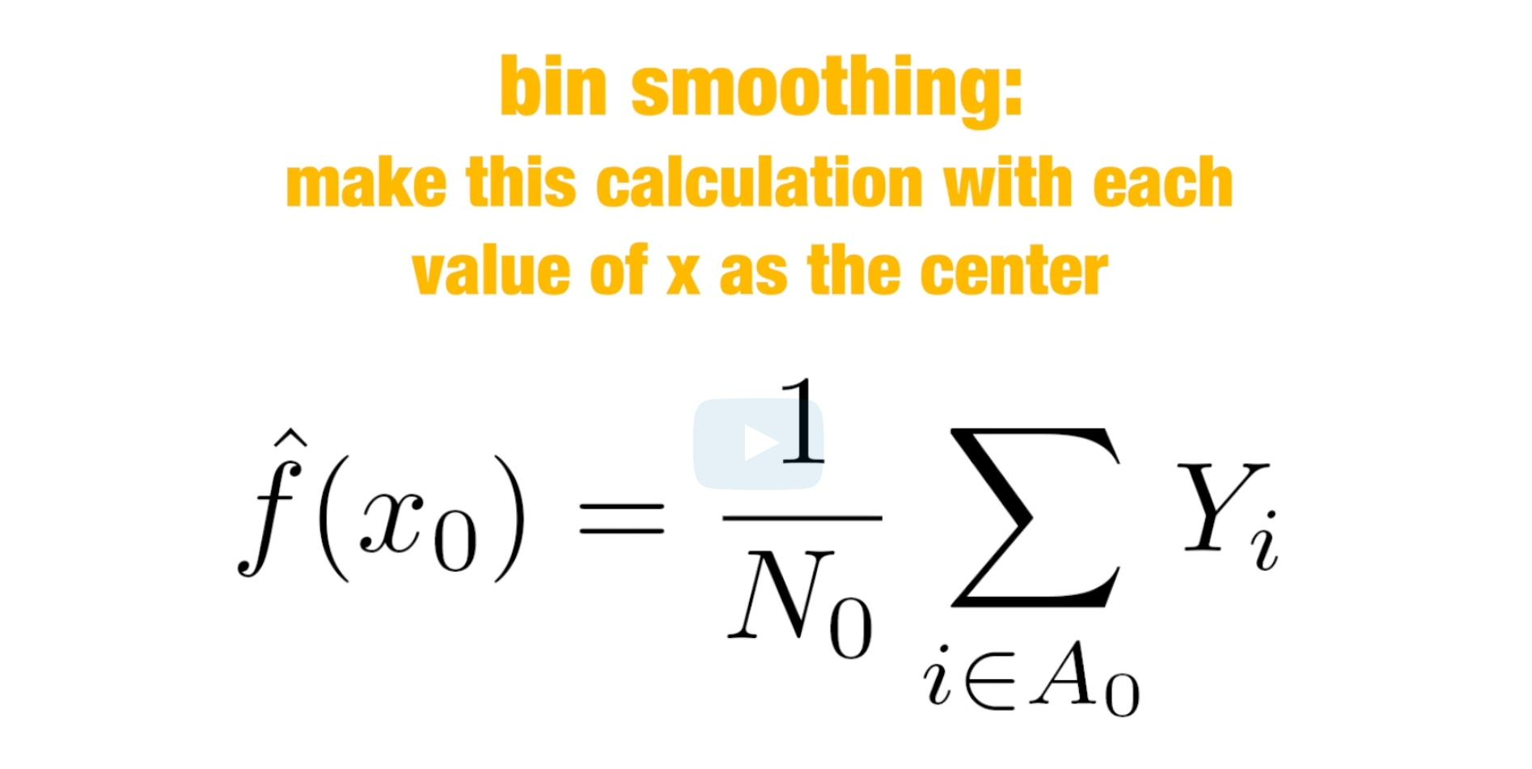

Bin smoother can be thought of as weighted average:

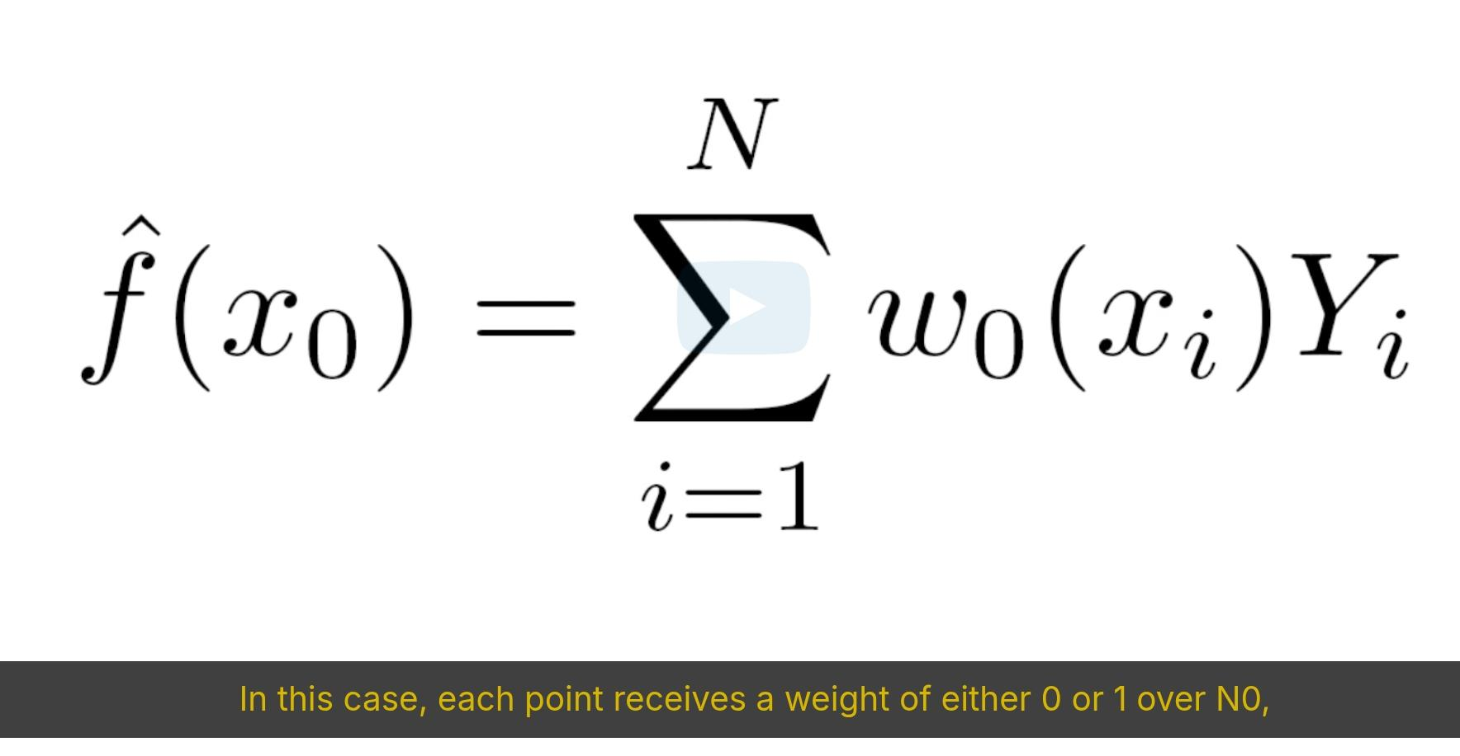

LOESS: Locally Estimated Scatterplot Smoothing
(Local Weighted Regression)
- instead of assuming the function to be locally constant, we assume it to be locally linear
- because of this assumption, we can use larger window size
- e.g. instead of a 1-week window, we can use a 3-week window:
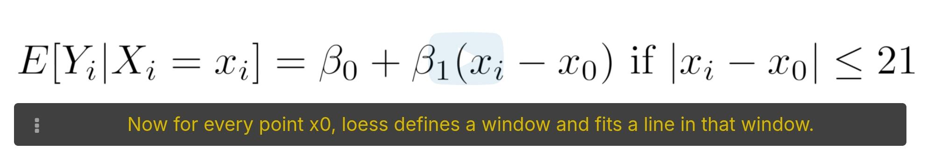
- this will have a smoother fit than our bin smoother earlier since we use larger window sizes

Taylor’s theorem states that if you look at any mathematical function closely, it will resemble a parabola.
- this means we can use an even larger window size and fit parabolas instead of lines
- ---> this is the default setting of loess() function:
loess( ...degree = 2); where 1 means line, 2 means parabola.
- so be careful with this default as sometimes it is not optimal

In our 2-or-7 machine learning example, our linear regression algorithm was not flexible enough to capture the non-linear nature of p(x1, x2).
---> smoothing approach may offer an improvement (like K-nn)

---

How to use loess()
* span to be used is 60 days
* transform first the date format to be numeric

span <- 60 / as.numeric(diff(range(pr_death_counts$date)))
fit_1 <- pr_death_counts %>% mutate(day = as.numeric(date)) %>%
loess(deaths ~ day, span = span, degree = 1, data = .)

Harvard solution:
pr_death_counts %>% mutate(smooth_1 = predict(fit_1, as.numeric(date))) %>%
ggplot() +
geom_point(aes(date, deaths)) +
geom_line(aes(date, smooth_1), lwd = 2, col = "red")

Pam solution:
puerto_rico <- pr_death_counts %>% mutate(day = as.numeric(date - min(date))
fit_1 <- loess(deaths ~ day, degree = 1, span = 60/1200, data=puerto_rico)
puerto_rico <- puerto_rico %>% mutate(smooth_1 = fit_1$fitted)
puerto_rico %>% ggplot(aes(day, deaths)) +
geom_point(color = "gray") +
geom_line(aes(day, smooth_1), color = "orange")

---
mnist_27 data set, loess predictor sample:

train_dat <- mnist_27$train %>%
mutate(y_dat = ifelse(y=="7", 1, 0), x_dat = x_2)
fit_1 <- loess(y_dat ~ x_dat, degree = 1, data = train_dat)
pred_val_test <- predict(fit_1, newdata = mnist_27$test, type = "response")
a <- ifelse(pred_val_test > 0.5, "7", "2") %>% factor(levels = levels(mnist_27$test$y))

# pred_val_test <- unname(pred_val_test)

mean(a == mnist_27$test$y, na.rm = TRUE)

----

Cross-validation

KNN
- similar to bin smoothing, but easier to adapt for larger dimensions
1. Define the distance between all observations based on the features
2. We look for the neighborhood (k nearest points)and take the average of 0’s and 1’s
3. This gives us an estimate of p(x1, x2). ← this is due to the connection between conditional expectations and conditional probabilities
4. We can control the flexibility with the “k-parameter”
- Larger k’s result in smoother estimates
- Smaller k’s result in more flexible and more wiggly estimates
- knn() function from the caret package
- [outcome] ~ [predictor 1] + [predictor 2] + [predictor n]
- [outcome] ~ . ← we use dot if we will use all the predictors
- e.g. knn_fit ← knn3(y ~ ., data = mnist_27$train, k=5) (default k is 5)
y_hat_knn ← predict(knn_fit, mnist_27$test, type = “class”)
confusionMatrix(y_hat_knn, mnist_27$test$y)$ overall [[Accuracy]]

Accuracy (when linear regression was used) = 75%
Accuracy (when knn was used) = 81.5%

- overtraining, at worst, is when k=1← this is like using the x_1, x_2 point to predict it’s self
- oversmoothing, when k is overly large, that it offers no flexibility, e.g. k = 400
- So we pick k that maximizes Accuracy and minimizes MSE (mean square error)
- The goal of cross-validation is to estimate these quantities for any given algorithm and any set of tuning parameters, such as k.

Exercise:
Use data(tissue_gene_expression) under caret package.
First, set the seed to 1 and split the data into training and test sets with p = 0.5. Then, report the overall accuracy you obtain from predicting tissue type using KNN with k = seq(1, 11, 2) using sapply() or map_df(). Note: use the createDataPartition() function outside of sapply() or map_df().

Pam solution:

set.seed(1)
indices <- createDataPartition(dat$y, times =1, p=0.5, list = FALSE)
dat <- tissue_gene_expression %>% data.frame()
str(dat)
trainT <- dat %>% slice(indices)
testT <- dat %>% slice(-indices)

ks <- seq(1, 11, 2)
k_fit <- knn3(y ~ ., data = dat, k = 1)
y_guess <- predict(k_fit, testT, type = "class")

accuracyT <- sapply(ks, function(x){
k_fit <- knn3(y ~ ., data = trainT, k = x)
y_guess <- predict(k_fit, testT, type = "class") %>% factor(levels = levels(testT$y))
mean(y_guess == testT$y)
})

accuracyT #potek mali yung nasa Harvard checking
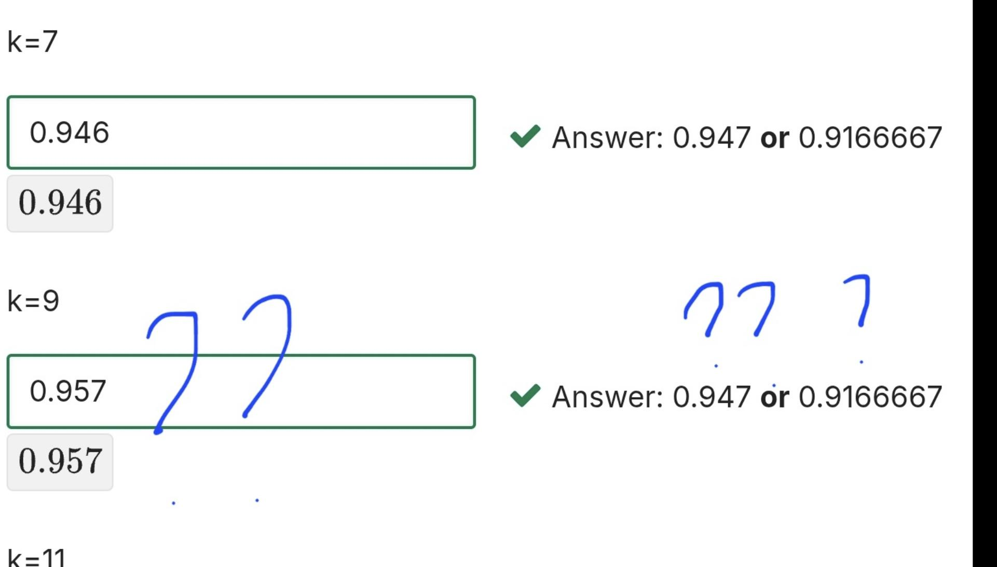

Harvard Solution:
set.seed(1)
y <- tissue_gene_expression$y
x <- tissue_gene_expression$x
test_index <- createDataPartition(y, list = FALSE)
sapply(seq(1, 11, 2), function(k){
fit <- knn3(x[-test_index,], y[-test_index], k = k)
y_hat <- predict(fit, newdata = data.frame(x=x[test_index,]),
type = "class")
mean(y_hat == y[test_index])
})

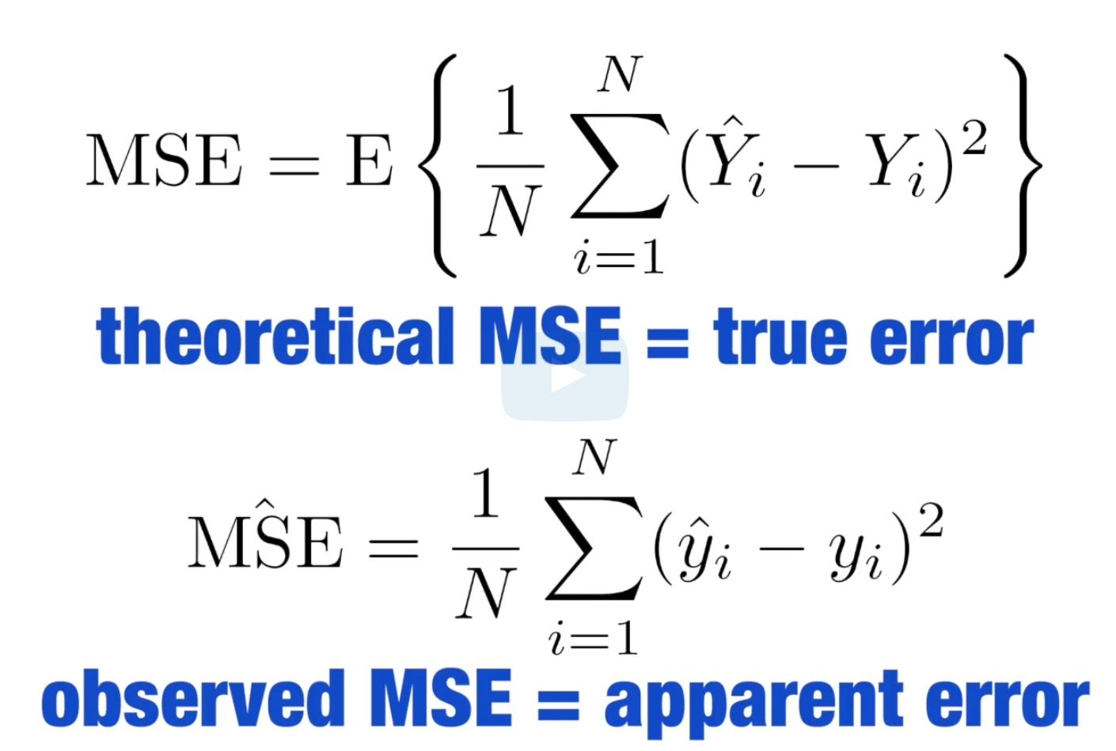





TRUE ERROR:
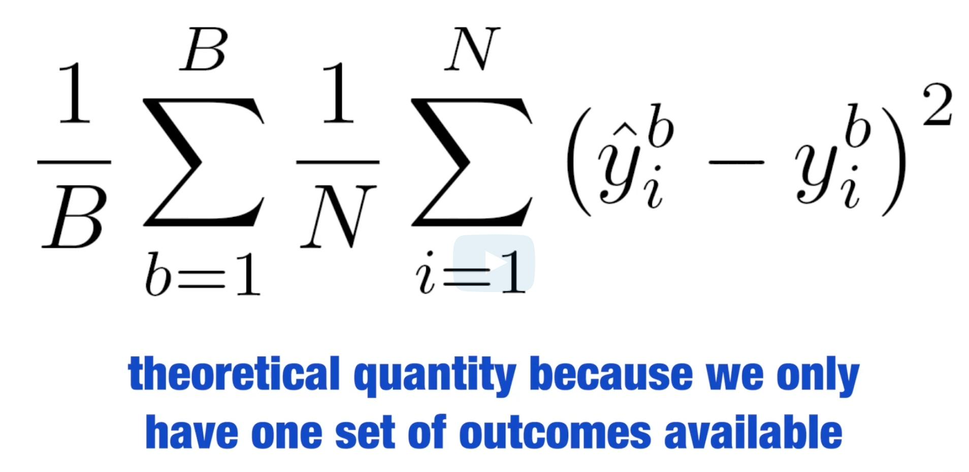

BOOTSTRAP
- when we don’t have access to the whole population, we can use bootstrap to estimate the population median m
- bootstrap permits us to approximate Monte Carlo simulation without access to the whole distribution
- the idea is simple:
- We act as if the observed sample is the population.
- We then sample data sets (with replacement) of the same sample size as the original dataset
- We compute the summary statistic, in this case median, on the bootstrap sample.
- Same idea with cross-validation: Instead of dividing data into equal partitions, we simply bootstrap many times.

## income <----- randomly distributed variable with size = 1 million

N <- 100
X <- sample(income, N)

B <- 10000
M_star <- replicate(B, {
X_star <- sample(X, N, replace = TRUE)
median(X_star)
})

## alternatively, we can use createResample() to generate bootstrap indices:
set.seed(1)
y <- rnorm(100, 0, 1)

set.seed(1)
indexes <- createResample(y, 10000)
q_75_star <- sapply(indexes, function(ind){
y_star <- y[ind]
quantile(y_star, 0.75)
})
mean(q_75_star)
sd(q_75_star)

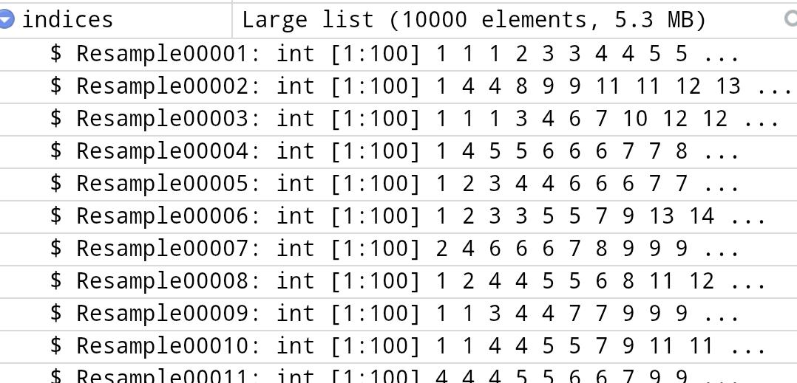

## getting the confidence interval:

quantile(M_star, c(0.025, 0.975))
## = (30253, 56909) , which is very close to the that of M (actual distribution gathered from doing monte carlo simulation of getting 100 samples from the entire population, 10,000 times, to get a distribution)

## Note: the CLT we studied produced a different confidence interval:
## median(X) + 1.96 * sd(X) / sqrt(N) * c(-1, 1)
## = (21017, 55904) <------ 95% interval based on CLT, which is quite far from the actual above

CARET PACKAGE
- train(): train_glm <- train (y ~ ., method = “glm”, data = mnist_27$train)
- predict(): y_hat_glm <- predict (train_glm, mnist_27$test, type=”raw”)
- to get accuracy: confusionMatrix(y_hat_glm, mnist_27$test$y)$overall[[“Accuracy”]]
- if the method used has tuning parameter (like k), train() uses cross-validation to decide among the default values that it tries
  - to get more info: getModelInfo(“knn”) or modelLookup(“knn”)
  - argument “highlight” highlights the max: ggplot(train_knn, highlight = TRUE)
  - default: cross-validation here takes 25 bootstrap samples comprised of 25% of the observation
  - tuneGrid parameter customizes the default k’s used:
train_knn <- train ( y ~ . , method = “knn”,
data = mnist_27$train,
tuneGrid = data.frame( k = seq (9, 67, 2) ))
ggplot ( train_knn, highlight = TRUE )

## to get the k that produced the highest accuracy:
train_knn$bestTune # k = 27
train_knn$finalModel # “27 nearest neighbor: Training set outcome distribution”

## predict() will use this best model when applied to the test set
y_guess <- predict( train_knn, mnist_27$test, type = “raw”)
confusionMatrix ( y_guess, mnist_27$test$y )$overall[[ “Accuracy” ]]

- train_control() : to change how the cross-validations are done
  - we can make our code run a bit faster:
Using 10-fold cross validation (which means 10 samples of 10% of the observations each):
train_control <- trainControl(method = “”cv””, number = 10, p = .9)
train_knn_cv <- train ( y ~ . , method = “knn”,
data = mnist_27$train,
tuneGrid = data.frame( k = seq(9, 67, 2) ))
trControl = train_control)
ggplot ( train_knn_cv, highlight = TRUE )
- to optimize further, we use loess:
install.package(“gam”)
modelLookup(“gamLoess”) # where we have 2 params to optimize:
# span & degree
- we can stick to degree = 1 and check different spans:
grid <- expand.grid(span = seq(0.15, 0.65, len = 10), degree = 1)

- then we use the default cross-validation parameters:
train_loess <- train ( y ~ . , method = “gamLoess”,
tuneGrid = gird,
data = mnist_27$train )
ggplot (train_loess, highlight = TRUE )

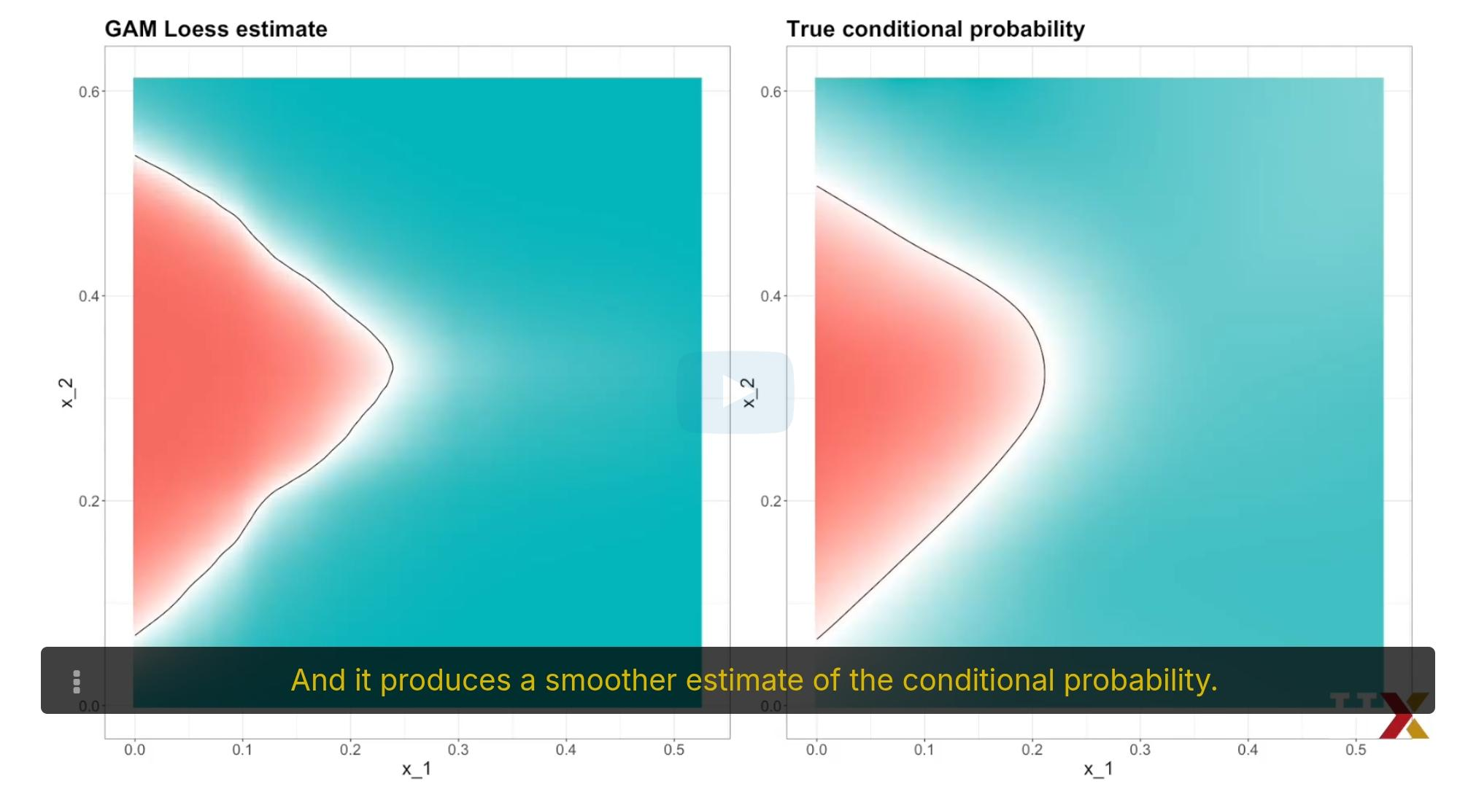

CROSS-VALIDATION Exercise:
Generate a set of random predictors and outcomes using the following code:

library(tidyverse)
library(caret)

set.seed(1996)
n <- 1000
p <- 10000
x <- matrix(rnorm(n*p), n, p)
colnames(x) <- paste("x", 1:ncol(x), sep = "_")
y <- rbinom(n, 1, 0.5) %>% factor()

x_subset <- x[ ,sample(p, 100)]

Because x and y are completely independent, you should not be able to predict y using x with accuracy much greater than 0.5. Confirm this by setting the seed to 1 and running cross-validation using logistic regression to fit the model. Because we have so many predictors, we selected a random sample x_subset. Use the subset when training the model.

set.seed(1)
fit <- train(x_subset, y, method = "glm")
fit$results

Now, instead of using a random selection of predictors, we are going to search for those that are most predictive of the outcome. We can do this by comparing the values for the group to those in the group, for each predictor, using a t-test. We can perform this step like this:
pvals <- rep(0, ncol(x))
for (i in 1:ncol(x)) {
pvals[i] <- t.test(x[,i][y==0], x[,i][y==1], var.equal=TRUE)$p.value
}
Create an index ind with the column numbers of the predictors that were "statistically significantly" associated with y. Use a p-value cutoff of 0.01 to define "statistically significantly."
How many predictors survive this cutoff? # Answer: 108
ind <- which(pvals <= 0.01)
length(ind) # Answer: 108
Now set the seed to 1 and re-run the cross-validation after redefinining x_subset to be the subset of x defined by the columns showing "statistically significant" association with y. What is the accuracy now? # Answer: 0.75

x_subset <- x[,ind]
set.seed(1)
fit <- train(x_subset, y, method = "glm")
fit$results # Answer : 0.75

Set the seed to 1 and re-run the cross-validation again, but this time using kNN. Try out the following grid k = seq(101, 301, 25) of tuning parameters. Make a plot of the resulting accuracies.
set.seed(1)
fit <- train(x_subset, y, method = "knn", tuneGrid = data.frame(k = seq(101, 301, 25)))
ggplot(fit)

In the previous exercises, we see that despite the fact that x and y are completely independent, we were able to predict y with accuracy higher than 70%. We must be doing something wrong then.
What is it?
# Answer: We used the entire dataset to select the columns in our model

TREE BASED METHODS:
- Classification and Regression Tree (CART) methods
- Random Forest
Other methods like LDA and QDA are not to be used with many predictors p bec. the # of params to be estimated becomes too large.
Curse of dimensionality: For kernel methods (i.e. KNN and local regression), when multiple predictors are used, the span/window size/neighborhood made becomes too large.
WIth larger neighborhoods, our method loses flexibility.
So when we have p predictors, the distance between 2 observations is computed in p-dimensional space.
A tree is a flowchart of yes and no.
We create trees with predictions at the end, called nodes.
When the outcome is continuous, we call it a regression tree.
When the outcome is categorical, we call it a classification tree, or a decision tree.
Regression and decision trees operate by predicting an outcome variable Y by partitioning the predictors.

